**Experiment NO 2:** Conversion Of Infix to postfix expression using Stack ADT

**Aim:** To convert infix expression to postfix expression using stack ADT

**Objective:**

I) Understand the use of stack

2) Understand how to import an ADT in an application program

3) Understand the instantiation Of Stack ADT in an application program

4) Understand how the member function of an ADT are accessed in an application program

Theory:

Infix expressions are readable and solvable by humans. We can easily distinguish the

order of operators, and also can use the parenthesis to solve that part first during

solving mathematical expressions. The computer cannot differentiate the operators

and parenthesis easily, that's why postfix conversion is needed.

To convert infix expression to postfix expression, we will use the stack data structure.

By scanning the infix expression from left to right, when we will get any operand,

simply add them to the postfix form, and for the operator and parenthesis, add them

In the stack maintaining the precedence of them.

**Algorithm:**

• Step I : Scan the Infix Expression from left to right.

• Step 2 : If the scanned character is an operand, append it with final Infix

to Postfix string.

• Step 3: Else,

Step 3.1 : If the precedence order of the scanned(incoming) operator is

greater than the precedence order of the operator in the stack (or the

stack is empty or the stack contains a '(' or or push it on stack.

Step 3.2 : Else, Pop all the operators from the stack which are greater

than or equal to in precedence than that of the scanned operator. After

doing that Push the scanned operator to the stack. (If you encounter

parenthesis while popping then stop there and push the scanned

operator in the stack.)

Step 4

If the scanned character is an '(' or '[' or 'C, push it to the stack.

Step 5 : If the scanned character is an ')'or or pop the stack and

and output it until a '(' or '[' or '{' respectively is encountered, and

discard both the parenthesis.

step 6

Repeat steps 2-6 until the infix expression is scanned.

step 7

Print the output

Step 8 • Pop and output from the stack until it is not empty.

**Program:**

#include<stdio.h>

#include<ctype.h>

char stack[100];

int top=-1;

void push(char x)

{

stack[++top]=x;

}

char pop()

{

if(top==-1)

return -1;

else

return stack[top--];

}

int priority(char x)

{

if(x=='(')

return 0;

if(x=='+' || x=='-')

return 1;

if(x=='*' || x=='/')

return 2;

return 0;

}

int main()

{

char exp[100];

char *e,x;

printf("Enter the expression: ");

scanf("%s",& exp);

printf("\n");

e=exp;

while(*e!='\0')

{

if(isalnum(*e))

printf("%c",*e);

else if(*e=='(')

push(*e);

else if(*e==')')

{

while((x=pop()) !='(')

printf("%c",x);

}

else

{

while(priority(stack[top])>=priority(*e))

printf("%c",pop());

push(*e);

}

e++;

}

while(top!=-1)

{

printf("%c",pop());

}

return 0;

}

**Output:**

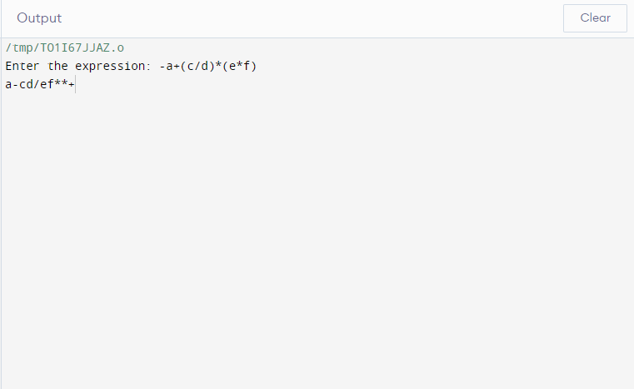

**Conclusion :** I) Infix notation is the notation in which operators come between the required

operands.

2) Postfix notation is the type of notation in which an operator comes after the operand.

3) Infix expressions can be converted to postfix expressions using stack.